**Project tittle : calculating family expenses**

**using service now**

* **Team id :**   **NM2025TMID18979**
* **Team members :**  **5**
* **Team leader : ARUN KUMAR A**
* **Team member 1: DEVENDRAN K**
* **Team member 2: IYYAPAN M**
* **Team member 3: GOKUL R**
* **Team member 4: ELUMALA P**

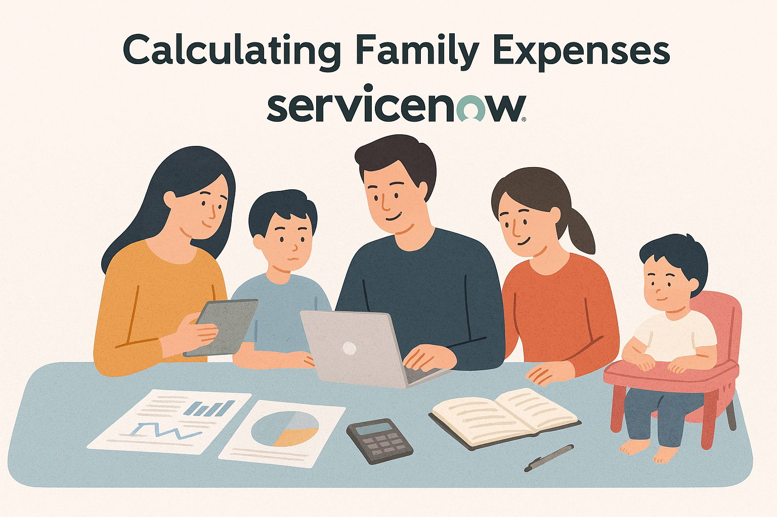

**User Story:**

To track and manage family's expenses efficiently through a ServiceNow application. This involves creating a feature that allows users to input expenses, categorize them, and generate reports for better financial management. Additionally, the application should provide alerts for overspending and allow for setting budget limits to help users stay within their financial goals.

**Project Overview:**

The project aims to develop a comprehensive expense calculation system using ServiceNow. This system will enable users to track and manage family expenses efficiently. It will include features such as expense categorization, budget setting, real-time tracking, and reporting capabilities. Utilizing ServiceNow's robust platform, the project will ensure seamless integration, user-friendly interface, and scalability to accommodate varying family sizes and financial complexities. The end goal is to empower users with the tools they need to make informed financial decisions and promote financial well-being within the family unit.

**Project Flow:**

Milestone 1 : Setting up ServiceNow Instance

Milestone 2 : Creation of New Update Set

Milestone 3 : Creation of Table(Family Expenses)

Milestone 4 : Creation of Table(Daily Expenses)

Milestone 5 : Creation of Relationship

Milestone 6 : Configuring Related List on Family Expenses

Milestone 7 : Creation of Business Rules

Milestone 8 : Configure the Relationship

Milestone 9 : Conclusion

# Milestone 1: Setting up ServiceNow Instance

1. Sign up for a developer account on the ServiceNow Developer site “https://developer.servicenow.com”.
2. Once logged in, navigate to the "Personal Developer Instance" section.
3. Click on "Request Instance" to create a new ServiceNow instance.
4. Fill out the required information and submit the request.
5. You'll receive an email with the instance details once it's ready.
6. Log in to your ServiceNow instance using the provided credentials.
7. Now you will navigate to the ServiceNow.

# Milestone 2: Creation of New Update Set

1. Go to All >> In the filter search for Local Update set > click on New.

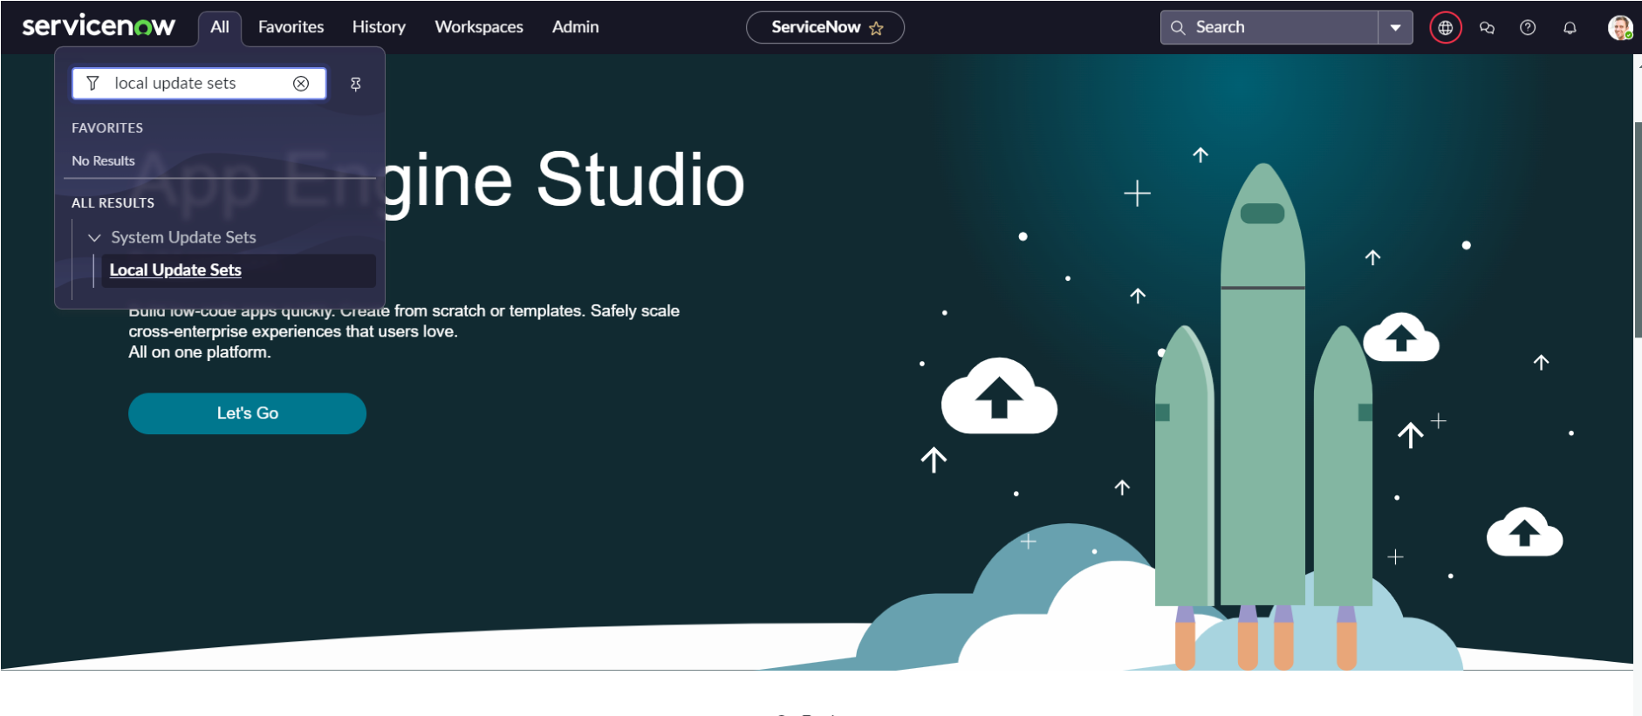

1. Enter the Details as:

Name : Family Expenses

1. Then click on Submit and Make current.

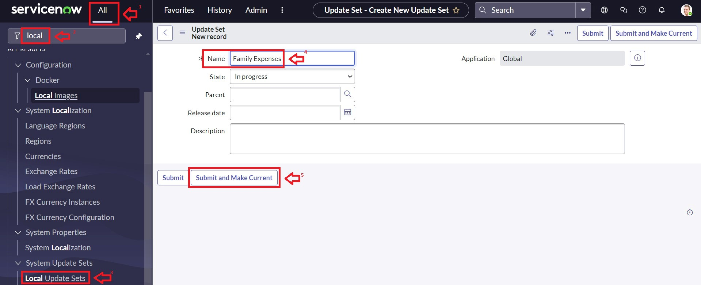

# Milestone 3: Creation of Table(Family Expenses)

## Activity 1: Creation of Family Expenses Table

1. Go to All > In the filter search for Tables > click on New.
2. Enter the Details: Label : Family Expenses

Name : Auto-Populated

New menu name : Family Expenditure

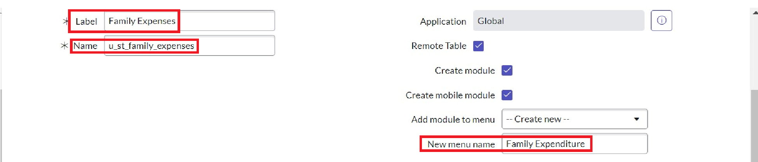

1. Go to the Header and right click there>> click on Save.

**Activity 2: Creation of Columns(Fields):**

1. Near Columns Double click near insert a new row.
2. Give the details as:

Column label : Number

Type : String

1. Double click on insert a new row again
2. Give the details as: Column label : Date

Type : Date

1. Double click on insert a new row again
2. Give the details as:

Column label : Amount

Type : Integer

1. Double click on insert a new row again
2. Give the details as:

Column label : Expense Details

Type : String

Max length : 800

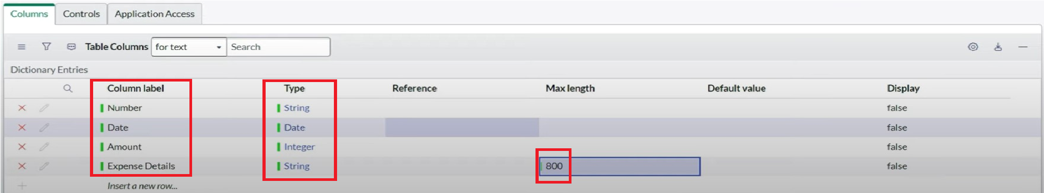

1. Go to the Header and right click there>> click on Save.

## Activity 3: Making Number Field an Auto-Number

1. Double click on the Number Field/Column.
2. Go down and double click on Advanced view
3. In Default Value:

Use dynamic default : check the box

Dynamic default value : Get Next Padded Number

1. Click on Update.
2. 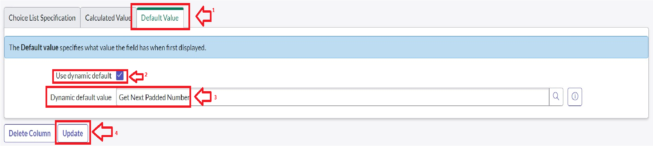
3. Go to All >> In the filter search for Number Maintenance >> select Number Maintenance
4. Click on New.
5. Enter the below Details:

Table : Family Expenses

Prefix : MFE

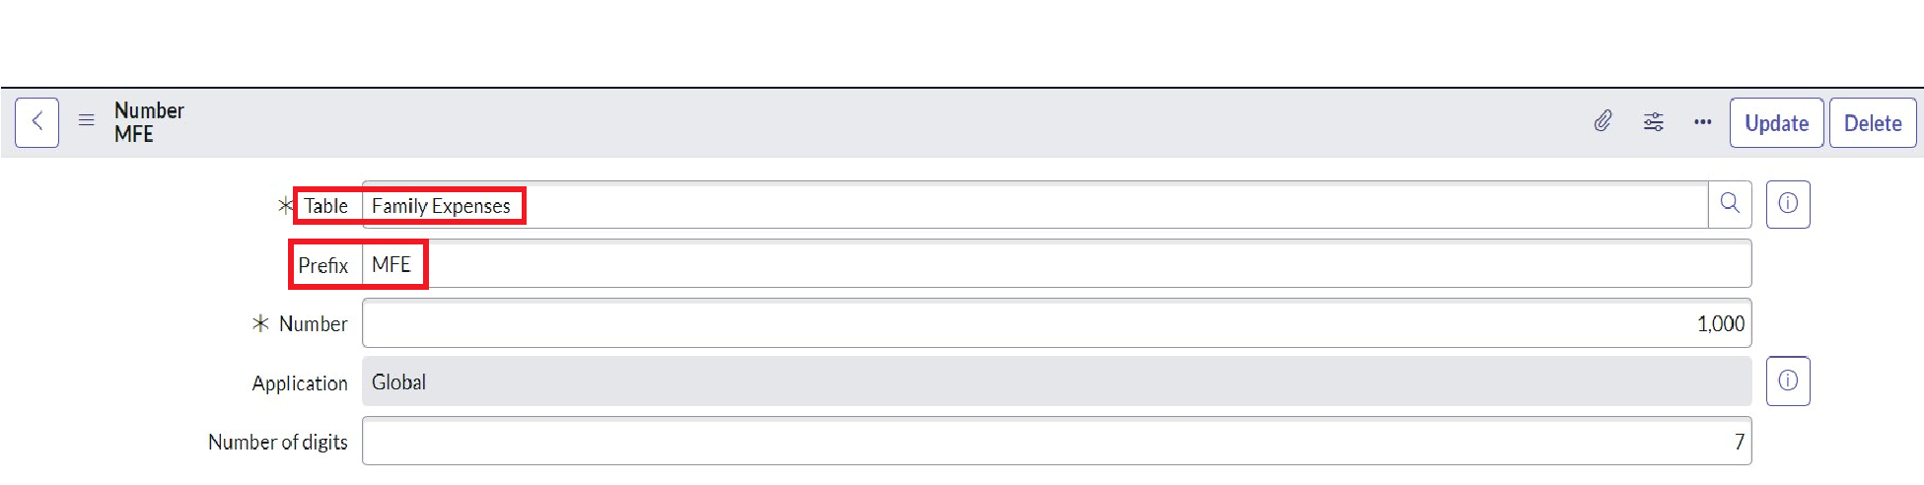

1. Click on Submit.

**Activity 4:**

1. Go to All >> In the filter search for Family Expenses >> Open Family Expenses
2. Click on New
3. Go to the Header and right click there>> click on Configure >> Select Form Design
4. Customize or Drag Drop the form as per your requirement.

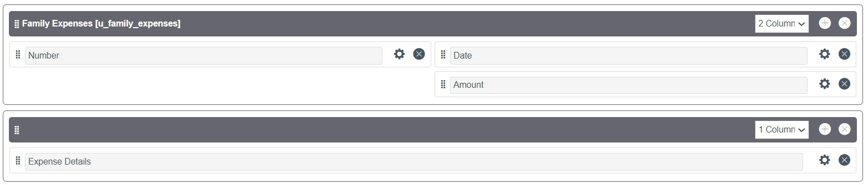

1. Make Number Read-Only Field by clicking on the gear icon and checking Read-Only 6. Make Date, Amount Mandatory Field by clicking on the gear icon and checking Mandatory

7. Click on Save.

# Milestone 4: Creation of Table(Daily Expenses)

## Activity 1: Creation of Daily Expenses Table

1. Go to All > In the filter search for Tables > click on New.
2. Enter the Details: Label : Daily Expenses

Name : Auto-Populated

Add Module to menu : Family Expenditure

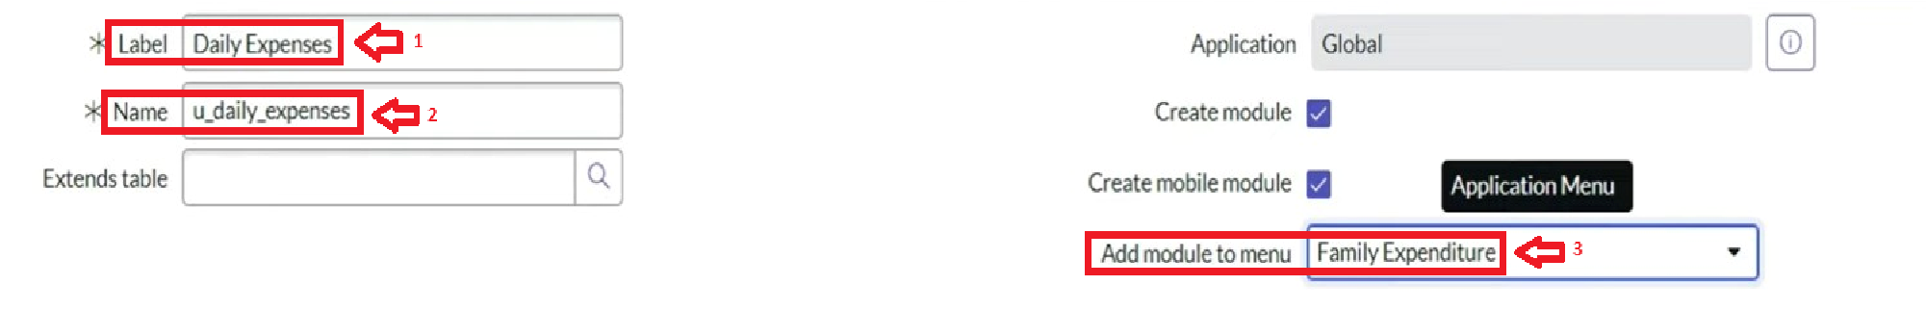

1. Go to the Header and right click there>> click on Save.

**Activity 2: Creation of Columns(Fields):**

1. Near Columns Double click near insert a new row.
2. Give the details as:

Column label : Number

Type : String

1. Double click on insert a new row again
2. Give the details as:

Column label : Date

Type : Date

1. Double click on insert a new row again
2. Give the details as:

Column label : Expense

Type : Integer

1. Double click on insert a new row again
2. Give the details as:

Column label : Family Member Name

Type : Reference

Max length : 800

1. Double click on insert a new row again
2. Give the details as:

Column label : Comments

Type : String

Max length : 800

1. Go to the Header and right click there>> click on Save.

## Activity 3: Making Number Field an Auto-Number

1. Double click on the Number Field/Column.
2. Go down and double click on Advanced view
3. In Default Value:

Use dynamic default : check the box

Dynamic default value : Get Next Padded Number

1. Click on Update.
2. 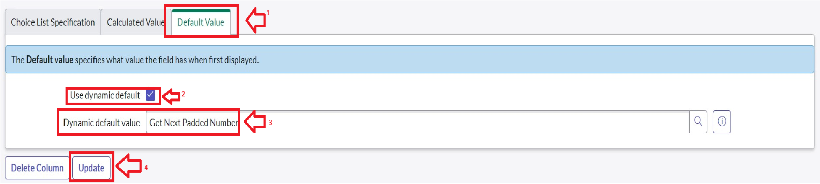
3. Go to All >> In the filter search for Number Maintenance >> select Number Maintenance
4. Click on New.
5. Enter the below Details:

Table : Family Expenses

Prefix : MFE

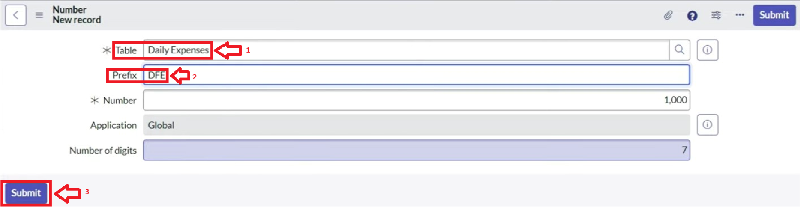

1. Click on Submit.

## Activity 4: Configure the Form

1. Go to All >> In the filter search for Daily Expenses >> Open Daily Expenses
2. Click on New
3. Go to the Header and right click there>> click on Configure >> Select Form Design 11. Customize or Drag Drop the form as per your requirement.

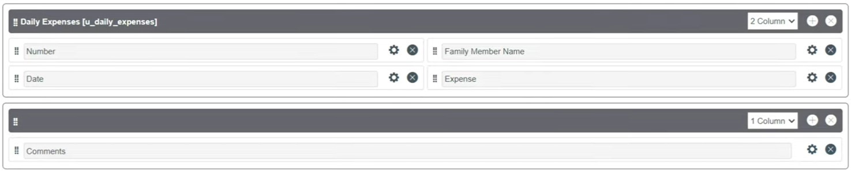

1. Make Number Read-Only Field by clicking on the gear icon and checking Read-Only
2. Make Date, Family Member Name Mandatory Field by clicking on the gear icon and checking Mandatory
3. Click on Save.

# Milestone 5: Creation of Relationship

## Activity 1: Creation of Relationship between Family Expenses and Daily Expenses tables

1. Go to All >> In the filter search for Relationships >> Open Relationships
2. Click on New.
3. Enter the details:

Name : Daily Expenses

Applies to table : Select Family Expenses

Daily Expenses : Select Daily Expenses

1. Click Save.

# Milestone 6: Configuring Related List on Family Expenses

1. Go to All >> In the filter search for Family Expenses >> Open Family Expenses
2. Click on New
3. Go to the Header and right click there>> click on Configure >> Select Related Lists
4. Add Daily Expenses to the Selected Area.
5. Click on Save

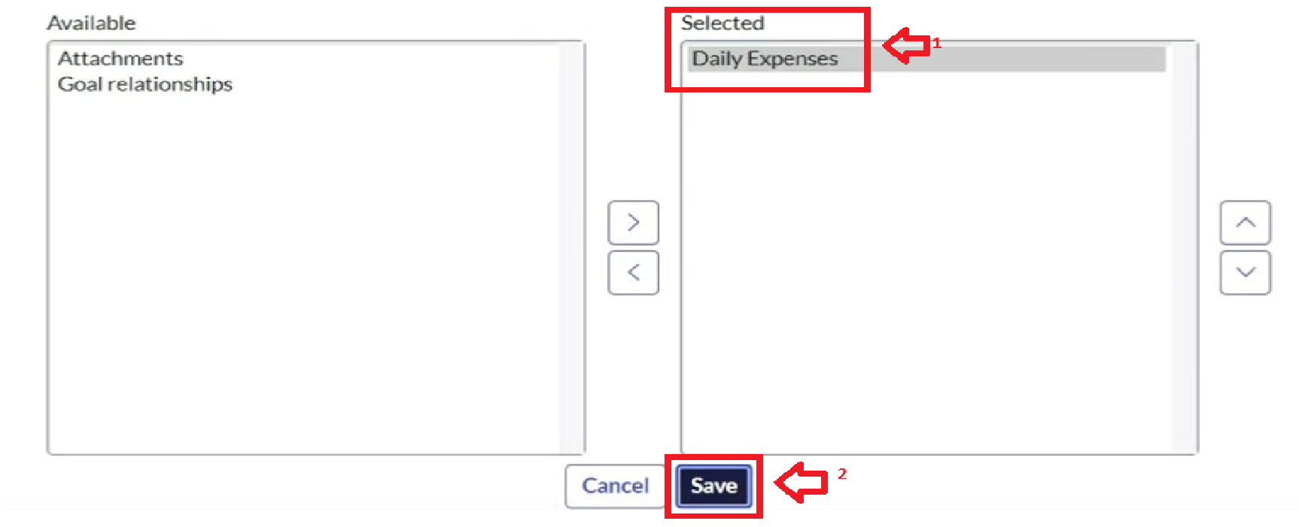

# Milestone 7: Creation of Business Rules

1. Go to All >> In the filter search for Business Rules.
2. Under System Definition Select Business Rules then click on New.
3. Enter the Details:

Name : Family Expenses BR

Table : Select Daily Expenses

Check Advanced

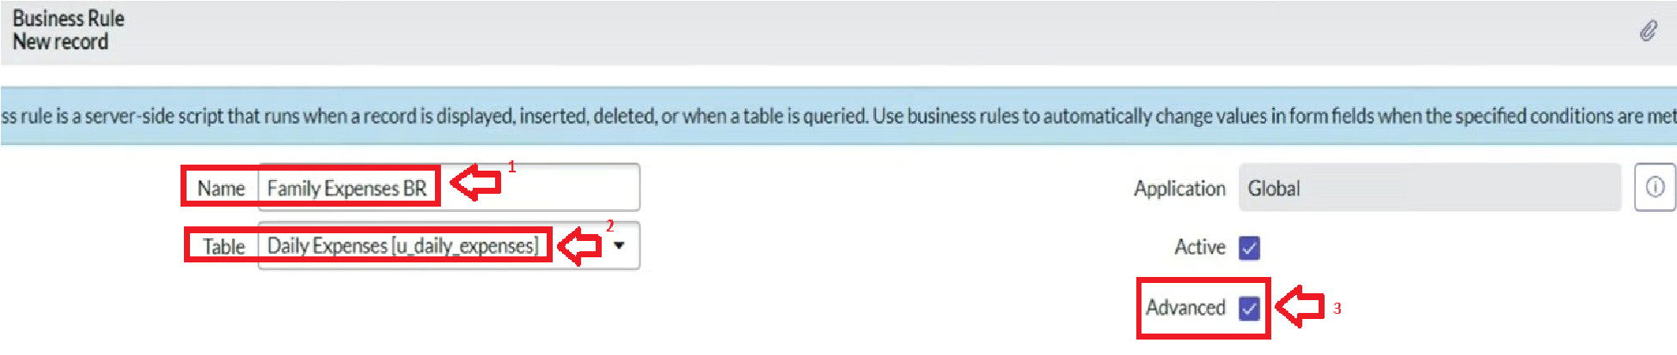

1. In when to run Check Insert and Update

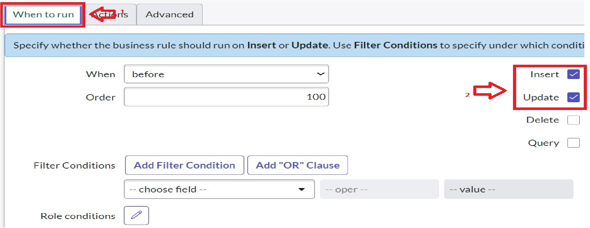

1. In Advance(we write the code): Write the below code >>

(function executeRule(current, previous /*null when async*/) {

var FamilyExpenses = new GlideRecord('u_family_expenses');

FamilyExpenses.addQuery('u_date',current.u_date); FamilyExpenses.query(); if(FamilyExpenses.next())

{

FamilyExpenses.u_amount += current.u_expense;

FamilyExpenses.u_expense_details +=

">"+current.u_comments+":"+"Rs."+current.u_expense+"/-";

FamilyExpenses.update();

}

else

{

var NewFamilyExpenses = new GlideRecord('u_family_expenses');

NewFamilyExpenses.u_date = current.u_date;

NewFamilyExpenses.u_amount = current.u_expense;

NewFamilyExpenses.u_expense_details +=

">"+current.u_comments+":"+"Rs."+current.u_expense+"/-";

NewFamilyExpenses.insert();

}

})(current, previous);

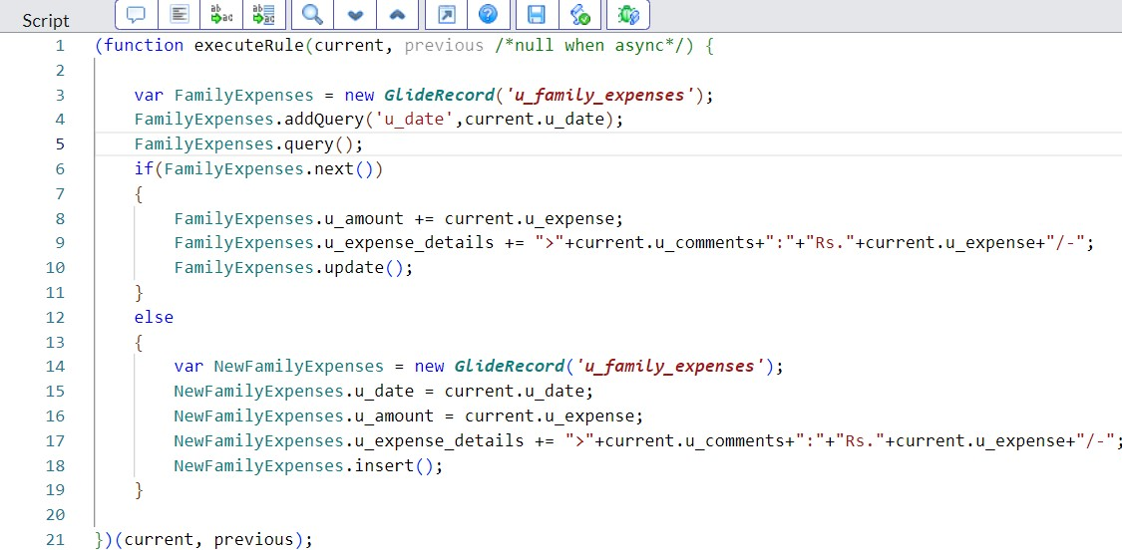

6. Go to the Header and right click there>> click on Save.

# Milestone 8: Configure the Relationship

1. Go to All >> In the filter search for Relationships >> Open Relationships.
2. In that, open a Daily Expenses Relationship.
3. For Applies to table : Select Family Expenses.
4. In Query with : write the below Query.

(function refineQuery(current, parent) {

// Add your code here, such as current.addQuery(field, value); current.addQuery('u_date',parent.u_date); current.query();

})(current, parent);

1. Click on Update.

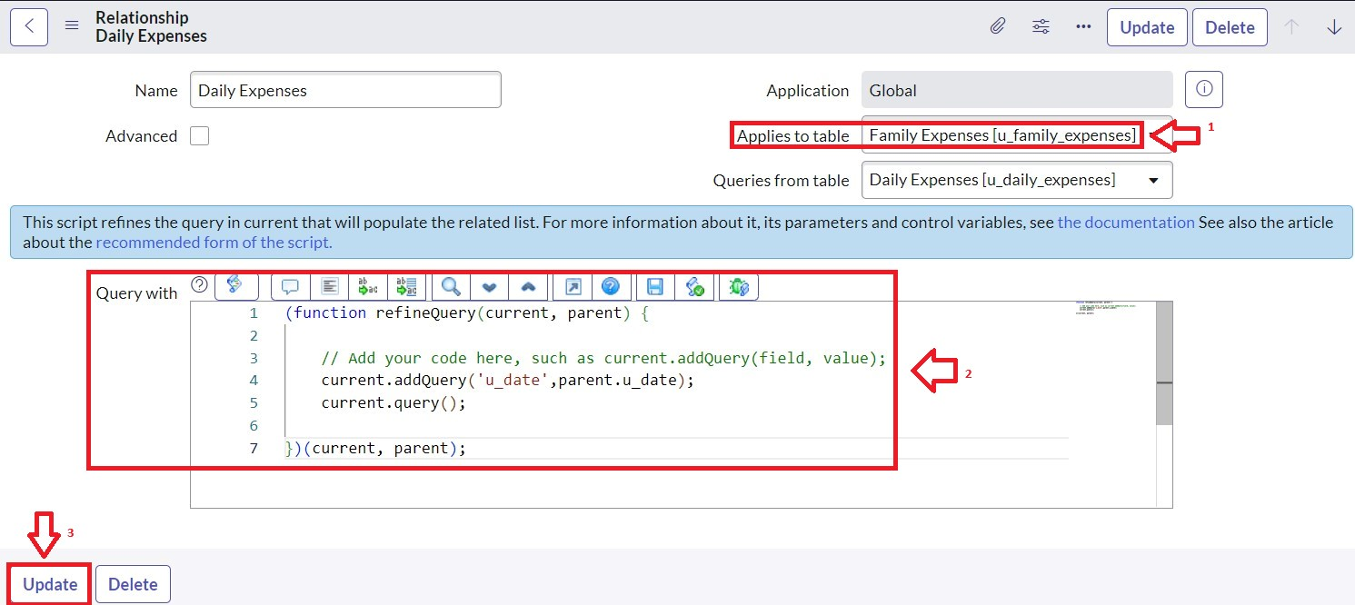

# Milestone 9: Conclusion

In conclusion, implementing the "Calculation of Family Expenses Using ServiceNow" project offers numerous benefits to the household. By leveraging the robust capabilities of ServiceNow, family members can efficiently submit, track, and manage their expenses in a centralized and streamlined manner.